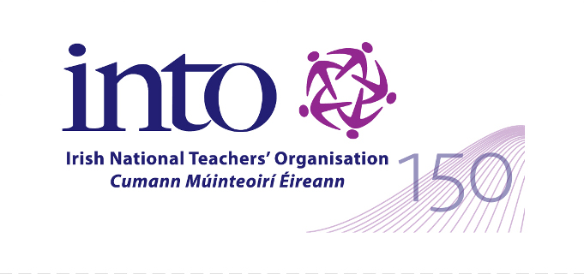

INTO – DCU PhD Scholarship at the Institute of Education, DCU
APPLICATION FORM
FOIRM IARRATAIS

Completion of this form is the initial application stage for the award. Please attach a CV with your application form. Following consideration of the application forms, a short list of candidates will be drawn up. In the final selection process, a 1500 word proposal will be sought.
Please complete in Block Capitals or Typescript
Bain úsáid as bloc litreacha nó cló, le do thoil

Personal Details / Sonraí Pearsanta
Name / Ainm
Contact Address (HOME)
Seoladh Baile
Telephone Number / Uimhir Ghutháin
Please include area code / Cód ceantair san áireamh
E-Mail / Ríomhphost
Teaching Position / Post Múinteoireachta
School Details / Sonraí Scoile
School Roll Number / Uimhir Rolla
School Name / Ainm na Scoile
Membership Details / Sonraí Ballraíochta
INTO Membership Number
Uimhir Bhallraíochta CMÉ

Teaching Council Registration Number
Uimhir Bhallraíochta an Chomhairle Mhúinteoreachta
Details of Third Level Qualifications and Relevant Professional Experience:
Sonraí Acadúla Tríú Leibhéal agus Taithí Gairmiúla
 | Undergraduate Degree |  | Postgraduate  Degree | Other
Title of Award
Level/Class of Award (H1,H2.1,H2.2, H3, Pass)
Name of Awarding Body
Institution Attended
Taught or Research programme
Period of Attendance
Date of Award
Main Subjects Studied

OTHER RELEVANT ACADEMIC OR PERSONAL DETAILS
(No more than 500 words)
SONRAÍ ACADÚLA NÓ PEARSANTA EILE, A BHAINEANN LE hÁBHAR
(Gan níos mó ná 500 focal)

SHORT DESCRIPTION OF RESEARCH TOPIC OR RESEARCH QUESTION IN WHICH YOU WOULD LIKE TO ENGAGE FOR PhD STUDY: (No more than 500 words)

GEARRCHUNTAS AR AN ÁBHAR NÓ CEIST TAIGHDE AR SPÉIS LEAT: (Gan níos mó ná 500 focal)

The award is contingent on the applicant meeting all the requirements for admission to doctoral studies at DCU (http://www4.dcu.ie/registry/postgraduate/index.shtml#Entry) and, following the initial selection process, a detailed research proposal being developed with the Executive Dean of the DCU Institute of Education and approved by the Faculty Research Admissions Panel, and documentation approved by DCU Registry.

DECLARATION / DEARBHÚ
I declare that the above particulars are correct and agree to abide by the circulated “Terms and Conditions” of this PhD.
Dearbhaím go bhfuil na sonraí thuas cruinn agus toilím glacadh le coinníollacha agus téarmaí an PhD.

Signature of Applicant
Siniú an iarrthóra
Date / Dáta

PLEASE COMPLETE and SUBMIT WITH A CV TO:
COMHLÁNAIGH AGUS SEOL AR AIS CHUIG:

Education Section An Rannóg Oideachais
INTO Cumann Múinteoirí Éireann
35 Parnell Square 35 Cearnóg Pharnell
Dublin 1 Baile Átha Cliath 1

Closing Date: Wednesday 31 January, 2018
Dáta Deireannach: Dé Céadaoin 31 Eanáir 2018
Email: education@into.ie

