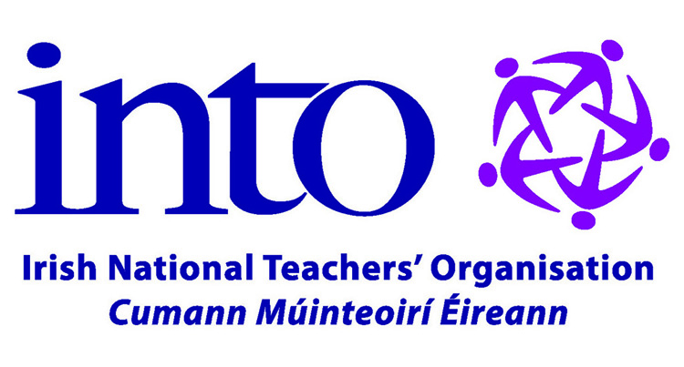 | Bursary Scheme 2023  Sparántachtaí  Terms and Conditions

Applicants must hold full membership of the INTO (Honorary and Associate members are not eligible to apply).

Applicants must be registered at a recognised third level institution during 2023. Bursaries shall not be awarded retrospectively or prior to registration, or if involved in a research project associated with an institution.

Criteria for selection of particular research projects will be at the discretion of an independent assessor, but he or she will be asked to bear in mind:
- Current issues under consideration by the Organisation.
- That the selected projects should reflect the various categories of research (e.g. psychology, philosophy, curriculum and assessment, history, policy, administration, leadership etc.)
- That funding is made available for projects in a number of institutions.
- Geographical and gender balance.
- Copies of final research are to be made available to the INTO for its Library.
- Members may not receive more than one INTO bursary, over the course of their career.
- The decision of the independent assessor shall be endorsed by the Organisation’s Central Executive Committee. The decision of the Central Executive Committee is final. No correspondence shall be entered into.
- Applicants are asked to include in support of their application a description of their project, which should include information on the following aspects of their work:
- Description of the project for which the Bursary is being sought.
- Relative significance of the contribution that the proposed project will make to the area of study.
- Methodology.
- Progress to date (where applicable).
This description should not exceed 1,000 words. Applicants are asked not to exceed the stated word limits.
- Only complete applications forms shall be considered.
- Completed applications must be received (either by post or email) before the closing date (Monday 25 September 2023). Any applications received after the closing date shall not be considered.

