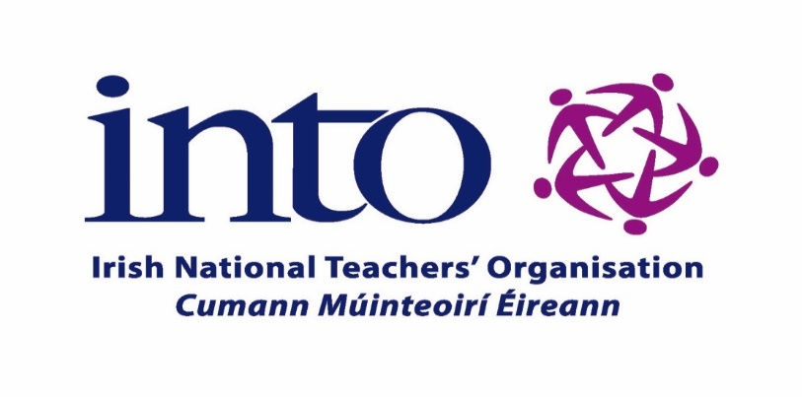

PRINCIPALS’ & DEPUTY PRINCIPALS’ BIENNIAL CONSULTATIVE CONFERENCE
Clayton Whites Hotel, Wexford
Friday 29th & Saturday 30th September 2023

Local Accommodation Options
for Friday 29th September

Click on each link to go to the website:

Clayton Hotel Wexford Town

Discover Ireland – Wexford Town

Visit Wexford-Accommodation

Bed & Breakfast Wexford

