International Women’s Day
Since 1911, International Women’s Day has been celebrated around the world on March 8. The United Nations formally proclaimed this date International Women's Day in 1975. The roots of International Women's Day can be traced back to the struggles of women workers in the late nineteenth and early twentieth centuries. Throughout history men and women have not had the same opportunities. Today women’s rights have come along way but despite this progress, there is still more work to be done. Around the world women have different rights and in some cases are not paid the same wage as men are for doing the same job.
International Women’s Day is an opportunity to celebrate the social, economic, cultural and political achievements of women, and a day when many people discuss the challenges that remain as women campaign for gender equality, empowering women and girls.
There are many ways to mark International Women’s Day in the primary classroom and initiate the important topic of gender equality.

Ideas for International Women’s Day

Children can be asked to interview an influential woman in their life (e.g.,
mother, grandmother, aunt, cousin, neighbour etc.)

Pupils could write a letter to a woman they admire.
Encourage children to think carefully about the questions that they would like to ask them.

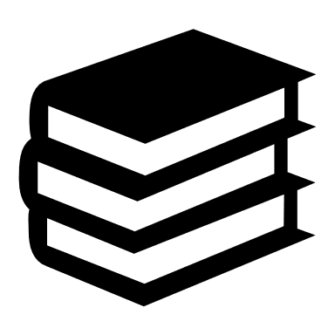Pupils could review a book written by a female author and present this to
their class

Children could choose an influential female figure as a focus for a project

Pupils can choose an important female and through ‘hot-seating’ in drama, classmates can ask questions to find out more about this person.

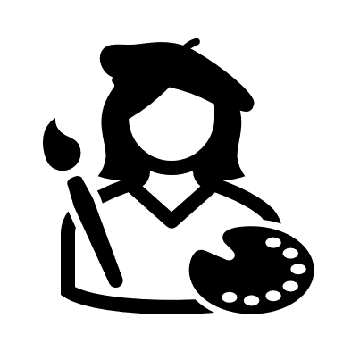Children can create a portrait, design a poster, or illustrate a timeline based on a chosen influential female figure.

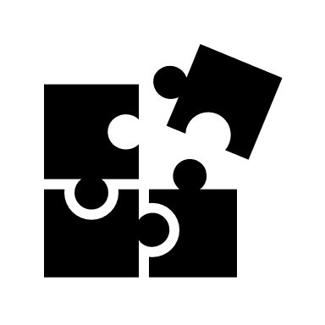Play games such as matching names of famous women to photographs, have a class quiz, 20 questions/guess the famous person.

Some useful resources/links
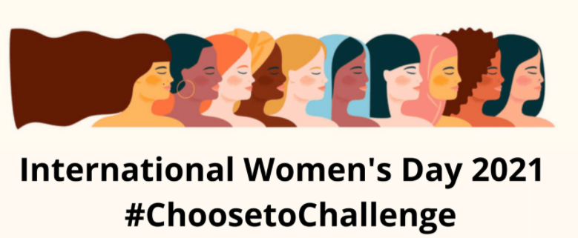

International Women’s Day website
The theme of International Women’s Day 2021 is #ChooseToChallengeA challenged world is an alert world. Individually, we all have a responsibility for our own thoughts and actions. The International Women’s Day website calls us to “choose to challenge” as “through challenge comes change”. Visit the website here

Minute of Listening website
Lesson plans and worksheets to teach children about the history of International Women’s day and give them an opportunity to consider why International Women’s Day is important.
Poster Template
International Women's Day worksheet
Response to music

Focus on Greta Thunberg
https://www.natgeokids.com/uk/kids-club/cool-kids/general-kids-club/greta-thunberg-facts/

Focus on Jacinda Ardern
https://kids.britannica.com/kids/article/Jacinda-Ardern/631798

Twinkl.ie
Twinkl.ie offer a range of printable resources in English and as Gaeilge for different class levels (including posters which teachers always find useful for creating a classroom display!) Some of these worksheets, puzzles, comprehensions and posters are available free of charge.
https://www.twinkl.ie/resource/roi2-h-40209-women-in-irish-history-display-facts-posters

International Women's Day Book Study
The International Women's Day Book Study provides in-depth material and lesson ideas encompassing literacy, history, drama and visual art objectives. It serves as an exciting and important introduction to the equality themes addressed in ‘Little Leaders: Bold Women in Black History’ - a beautifully illustrated book by Vashti Harrison, championing many women who have changed the world and in their own ways have all forged equality.
https://www.internationalwomensday.com/PuffinSchools
Women in history
Just some of the many inspiring and influential women in history that could be explored in class-based discussions:
Florence Nightingale https://www.natgeokids.com/uk/discover/history/general-history/florence-nightingale/
Marie Curie https://kids.britannica.com/kids/article/Marie-Curie/574599
Anne Frank https://www.natgeokids.com/uk/discover/history/general-history/anne-frank-facts/
https://alphahistory.com/holocaust/anne-frank-diary-1942-44/
Amelia Earhart https://kids.britannica.com/kids/article/Amelia-Earhart/353073
Helen Keller https://www.ducksters.com/biography/women_leaders/helen_keller.php
Rosa Parks https://www.natgeokids.com/uk/discover/history/general-history/rosa-parks/
Eleanor Roosevelt https://kids.nationalgeographic.com/history/article/eleanor-roosevelt
Joan of Arc https://kids.nationalgeographic.com/history/article/joan-of-arc
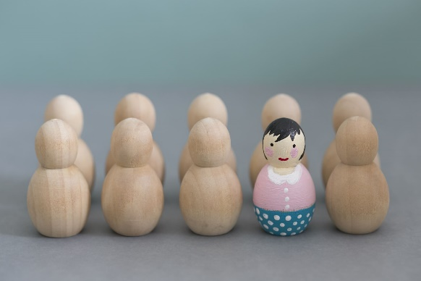

Authors 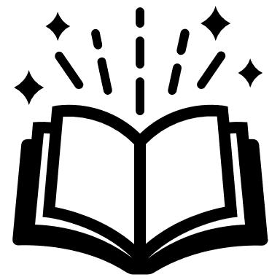
Enid Blyton https://kids.kiddle.co/Enid_Blyton
Beatrix Potter https://kids.britannica.com/kids/article/Beatrix-Potter/599838
J.K. Rowling https://www.ducksters.com/biography/j_k_rowling.php

Important Women in Irish History
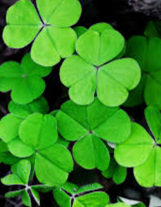
Pioneers of parliamentary politics
A lesson plan, slideshow, and printable worksheets about the history of women in Irish parliamentary politics suitable for pupils in 3rd/4th class can be found on the oireachtas.ie website https://www.oireachtas.ie/en/visit-and-learn/teachers-and-students/primary/
Further information can be found on the Vótáil100 pages https://www.oireachtas.ie/en/visit-and-learn/centenaries/votail-100/
Other material on the formation of Cumann na mBan is available on military archives.ie (Information on the events of April 1914, when over 100 women gathered in Dublin to discuss the role of women in the lead-up to revolution. They became Cumann na mBan - an organisation whose role in achieving Irish independence is almost forgotten).
This material is designed for older students, but teachers of senior classes may find some useful information and ideas. https://www.militaryarchives.ie/collections/online-collections/1916-in-transition-1916/search-lesson-plans/single?tx_r3lessonplan_pi1%5BshowUid%5D=17&cHash=657e7b8fc8495cf1958da091959b8118

Biographies of Irish women
The Royal Irish Academy’s Dictionary of Irish Biography - accessible for free to all schools via Scoilnet - features the biographies of over 1000 fascinating women’s stories from across the island of Ireland. Teachers may find it useful to search this database https://dib.cambridge.org/

Heritage in Schools website
The ‘Heritage in Schools’ website has a useful downloadable activity booklet with a feature on Kay McNulty (born in the Donegal Gaeltacht) who helped invent the first general purpose computer and tracked missiles during WWII.
http://www.heritageinschools.ie/teachers-resources/category/history

EPIC
Education resources are available on the EPC website including ‘Epic Characters in 30 seconds’ videos (with a video on Mary Mallon/Typhoid Mary who is one of history’s most famous infectious disease carriers).
https://epicchq.com/education/online-resources/

Influential Irish Women:
Mary Robinson https://kids.britannica.com/students/article/Mary-Robinson/313253
Mary Mc Aleese https://kids.britannica.com/students/article/Mary-McAleese/312432
Norah Patten is an Aeronautical Engineer from County Mayo (timely given that Engineer’s week came to an end on March 5th) Videos with Norah Patten (@spacenorah), aimed at children are available on RTÉ Junior.

Sonia O’Sullivan https://www.twinkl.ie/resource/roi2-e-2722-sonia-osullivan-differentiated-reading-comprehension-activity
Katie Taylor https://kids.kiddle.co/Katie_Taylor
(Other female sports stars feature in Jacqui Hurley’s book ‘Girls Play Too’). This can prompt a discussion among sports enthusiasts about the inequality experienced by Irish women and Irish men on the sporting front e.g., is it right that Irish international soccer players such as Rianna Jarrett and Katie Mc Cabe are not paid the same as Aaron Connolly and Shane Long?)

