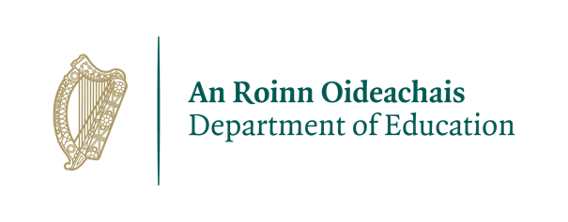
Arrangements for the end of term – Christmas 2020
End-of-term celebrations/gatherings

It is recognised that the end of each term is a significant milestone and often schools organise events and celebrations to mark the occasion. Celebration of these milestones is important to support positive wellbeing for pupils and students in schools. In this context, schools are reminded of the need to ensure that any plans for the remainder of the year are implemented in line with public health guidelines.

Current health and safety guidelines advise that gatherings be discouraged. Large school groups such as choirs should be avoided at present. Wind and brass instruments, including tin whistles and recorders, should not be played indoors due to the additional risk of infection such activity poses. Outdoor class performances and other precautions such as moisture guards for wind instruments may be considered as alternative options.

While the usual school assemblies should be avoided, class performances may be shared with other classes and parents/guardians using digital technologies such as the school website, the school’s digital platform and/or video-conferencing facilities, provided appropriate consent has been obtained from parents/guardians. Parents/guardians should not be invited to attend end-of-term celebrations this year. However, Christmas singing whilst maintaining social distancing and within normal pod structures can take place outdoors. Unfortunately, no parents / guardians will be allowed to attend these outdoor events either.

Pupils/students often like to share Christmas cards and small gifts. This is allowable but needs to be undertaken in a controlled manner, such that it does not involve pupils/students moving and interacting outside of their usual pods or contacts. Any cards/ gifts would ideally be given to a staff member directly, and then distributed by a staff member to pupils/students in a controlled way. There should be a strong emphasis on hand hygiene at all times.

End-of-term examinations in post-primary schools

Student learning is assessed on an ongoing basis in the classroom and schools provide opportunities for students to display their learning through a range of formative and summative assessments. Many schools choose to administer end-of-term examinations as part of this approach to assessment.

Schools have their own arrangements for how these examinations are usually organised. In implementing these arrangements this year, schools should continue to implement all public health guidelines in terms of physical distancing, wearing of masks, hand-hygiene and sanitisation to prevent and control the spread of COVID-19. Schools should consider administering end-of-term examinations to individual class groups in their classrooms rather than in large assembly-style groupings.

Teachers are reminded that they can continue to handle copybooks or exam papers completed by the students but there must be a strong emphasis on hand hygiene at all times.

