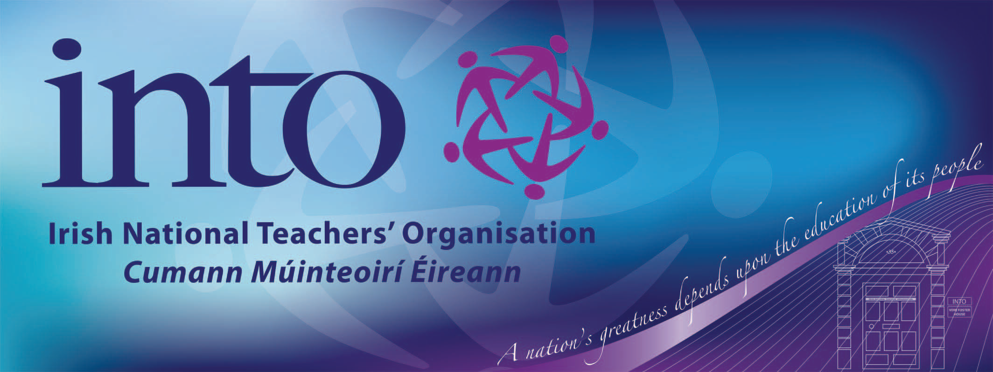
INTO
Vere Foster House
23 College Gardens
Belfast BT9 6BS

Phone: 028 90 38 14 55
Fax: 028 90 66 28 03
Email: infoni@into.ie
Web: www.into.ie
Twitter: INTO_NI

Members Update
Pay Award 2021-2023
11th March 2024

ETI Safeguarding Proforma 2019-20
21st August 2019

Dear Member,

Today the Northern Ireland Teachers' Council (NITC) has reached a draft agreement with Management Side which includes a pay offer for 2021-22, 2022-23 and 2023-24.

Northern Committee considered this proposed agreement in detail and having accepted that the proposed pay rises are the absolute maximum achievable, recommends that you accept it by voting YES in the forthcoming electronic survey, to be held between 14 and 20 March.
Members will be notified of an all-members online briefing before the survey opens.

The draft agreement includes:
A new starting salary of £30,000 from 1 September 2023, this will be delivered by removing M1 from the Main Pay Scale and uplifting point M2 to £30,000;
Teachers and School Leaders on all other points will receive a consolidated pay award equating to a cumulative total of 10.4% plus £1000.00. The £1000 is not one off and will be included in your salary going forward;
The award is based on an increase of 1% for 2021-22, 5% for 2022-23 and 4.1% plus £1000 for 2023-24;
In addition to the consolidated pay awards, all additional allowances will be increased by 1% for 2021-22, 5% for 2022-23 and 4.1% for 2023-24.
Details of back pay and frequently asked questions will be published soon.

Framework for the workforce reviews
A framework to address the recommendations contained in the 8 completed workforce reviews will be agreed by 31 May 2024. This framework will include a timetable for the implementation of those areas which can be progressed, both immediately and over a short to medium term. This will include the implementation of the revised TNC Workload Agreement from 1 August 2024 and the measures to address school leader workload which can be progressed.

Industrial Action
Acceptance of this offer will mean that industrial action will cease at the end of this term. The NITC is determined that no teacher or school leader will be required to 'catch up' on any work not done during industrial action and as part of this agreement there will be an agreed communication with management side in relation to carefully managed and supported restoration of working practices in schools.

What if the offer is not accepted?
All unions are convinced that this offer is the best offer available, and that rejection of the offer will not lead to an improved offer.
This offer was made as a result of the determination of all our members taking strike action and action short of strike. Teachers and school leaders have waited too long to settle the 2021-22, 2022-23 and 2023-24 pay claims and there will be no benefit to extending this process any further. The focus of the NITC going forward will be on pay restoration and our main focus going forward will be the 2024-25 pay claim.

Mark McTaggart
Northern Secretary
INTO Northern Office
Vere Foster House
23 College Gardens
Belfast
BT9 6BS
Tel: 028 9038145
Make your voice heard – join the largest most effective teaching union in Ireland

