An Roinn Oideachais agus Eolaíochta, Department of Education and Science,
Rannog Oideachais Muinteoiri, Teacher Education Section,
Bloc 2, Urlár1, Block 2, Floor1,
Sráid Maoilbhríde, Marlborough Street,
Baile Átha Cliath 1. Dublin1.
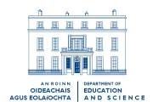

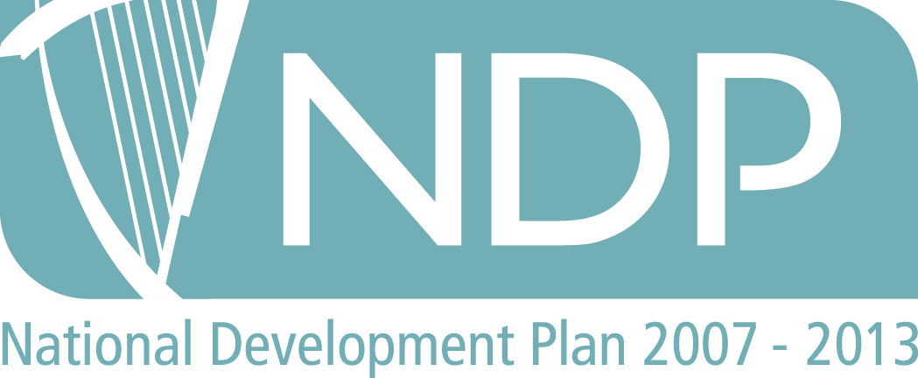

Circular : 0089/2007

Online Certificate/ Diploma in Special / Inclusive Education – 2007/2008

TO: THE AUTHORITIES OF PRIMARY And POST-PRIMARY SCHOOLS

- The Programme 2007/2008
The Special Education Department of St Patrick’s College, Drumcondra, and the Institute of Child Education and Psychology, Europe (ICEP) www.icepe.eu will jointly offer an online Certificate/Diploma in Special/Inclusive Education, open to both primary and post-primary teachers who wish to develop their knowledge and skills in the area of special/ inclusive education.

The programme is part-funded by the Teacher Education Section of the Department of Education and Science under the National Development Plan 2007 to 2013.

Up to 150 places will be available in the Programme for the year 2007-2008. This will consist of 75 places for primary school teachers and 75 places for post-primary teachers. These numbers are subject to change depending on demand.

- Aim and Content
The aim of the programme will be to develop teachers’ knowledge and skills in working with pupils with special and additional educational needs in mainstream classrooms.

A qualification of Certificate/ Diploma in Education will be awarded by Dublin City University. Participants will be assessed on the basis of coursework, tasks and written assignments relevant to professional practice, and a project on an approved topic in special educational needs/ inclusive education. Full participation in both the online and face-to-face aspects is expected. Further details will be made available to applicants by the Institute of Child Education and Psychology, Europe (ICEP) www.icepe.eu and/or the Special Education Department of St Patrick’s College.

- Duration and Organisation
Registration for this programme, of Continuous Professional Development (CPD), recognised by the Department of Education & Science will commence in the autumn of 2007.The certificate programme consists of four taught modules, and the diploma programme requires an additional module on research methods and a project of 7000-8000 words. The programme is delivered through online and distance learning modes. Programme duration is flexible to suit the needs of individual participants; however the certificate must be completed within 3 years and the diploma within 4 years from first registration. The foundation module (to be taken by all students) focuses on inclusive practice. Upon successful completion of this module participants will chose from a range of modules focusing on different aspects of special educational needs including: mild general learning disabilities, dyslexia, Autistic Spectrum Disorders, and challenging behaviour. Please note that successful completion of this programme will not result in any entitlement to additional remuneration from the Department of Education and Science

- Eligibility
In order to participate in the programme, teachers will need access to a computer and access to broadband is strongly recommended. Applicants should be currently employed in the Irish Education System, and. while all applicants will be considered; priority will be given to teachers in mainstream schools.

- Primary:

Applicants should have satisfactorily completed their probationary period. They must have recognised teaching qualifications in accordance with Circular 140/2006

- Post primary

Applicants must be qualified teachers.

- Applications and Selection
An Application Form accompanies this Circular for completion by teachers interested and eligible to participate in the programme.

Important
Eligible teachers supported by their school authorities who wish to be considered for admission to the Programme should send their applications to The Programme Director, Joint online Certificate/ Diploma in Education, Admissions, St Patrick’s College, Drumcondra, Dublin 9 to be received not later than 5pm on Friday October 12th 2007. Phone: (01) 884 2197
E-mail address: courseinfo@spd.dcu.ie . All applications must be accompanied by a non-returnable administration fee of €25. Applicants are advised that they should retain evidence of postage.

- Funding
Part funding for the programme is provided by the Teacher Education Section of the Department of Education and Science under the National Development Plan 2007 to 2013, as follows:

There will be a fee of €925 per module. The Department of Education and Science will pay 60% of the applicant’s programme fees (i.e. €555 per module) up to a maximum of 5 modules and a project per applicant. Individual applicants will be responsible for the 40% of their fees (i.e. €370 per module up to a maximum of 5 modules and a project and for 100% of fees for any additional modules. Note: Travel and subsistence will not be provided for any of the face-to-face elements.

As participants will not be required to be absent from school, the provision of substitute cover or of extra personal vacation (EPV) days will not be necessary.

- Master’s Programme

Credit from the Diploma in Education may be taken towards the Master in Education Degree subject to certain conditions, including the attainment of a sufficiently high standard in the Diploma and the availability of places on the masters’ programme.

Alan Wall
Principal Officer.
September 2007

Download Application Form (File Format Word 70K

Pending Accreditation

