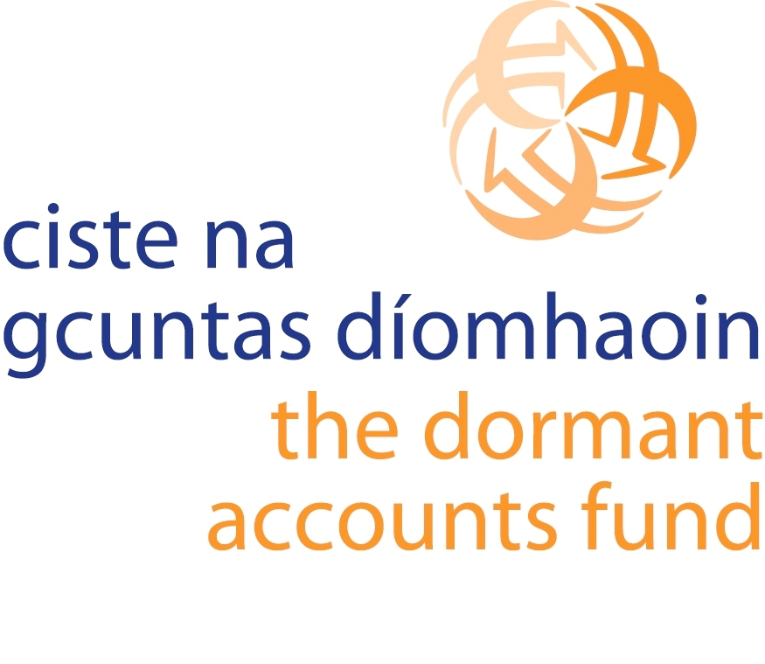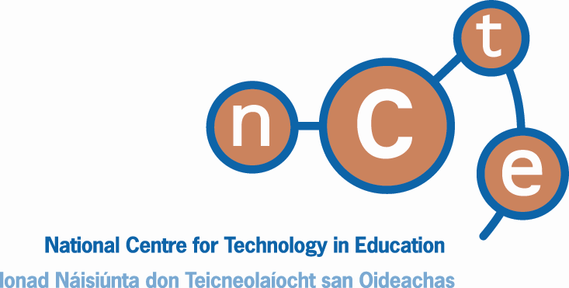

Circular 0100/2008

To: Boards of Management & Principals of the 100 Primary schools serving the most disadvantaged communities, participating in the School Support Programme under DEIS Urban Band 1 (Delivering Equality of Opportunity in Schools)

APPLICATION FOR GRANT AID

UNDER THE

DORMANT ACCOUNTS (EDUCATIONAL DISADVANTAGE) FUND

TO ASSIST SELECTED DEIS URBAN BAND 1 SCHOOLS TO PROGRESS TOWARDS ACHIEVEMENT OF DIGITAL SCHOOL STATUS

Completed forms must be returned by post or email no later than 5th December, 2008 to:

Neil O’Sullivan
Project Officer
Digital Schools
NCTE
DCU
Dublin 9

Email address: nosullivan@ncte.ie

DORMANT ACCOUNTS (EDUCATIONAL DISADVANTAGE) FUND
TO ASSIST SELECTED DEIS URBAN BAND 1 SCHOOLS TO PROGRESS TOWARDS ACHIEVEMENT OF DIGITAL SCHOOL STATUS

1. Introduction

The Minister for Education and Science is pleased to announce details of the above- mentioned scheme and to invite the 100 Primary Urban Band 1 DEIS schools serving the most disadvantaged communities to apply for funding in accordance with the terms of this Circular Letter.

The Digital Schools Award is an initiative which recognises excellence in a school’s approach to integrating information and communications technology (ICT) in its learning and teaching. The Award considers the school’s approach across the following five key areas:

- Leadership and Vision
- ICT in the Curriculum
- School ICT Culture
- ICT Professional Development
- Resources and Infrastructure

The NCTE coordinates the Digital Schools Initiative, which has been developed in partnership with the INTO, IPPN and CESI. Further details on the Digital Schools Award are available at the website www.digitalschools.ie

This scheme provides for grants to schools up to a maximum of €20,000 in any individual case, to assist them to progress towards achievement of Digital School status. Funding will be devolved to individual school authorities to purchase ICT resources which may include computer hardware, software, peripherals, digital equipment and networking infrastructure. Schools are reminded of the ICT support service provision of the NCTE in relation to equipment purchase, continuous professional development for teachers and online teaching and learning resources (through Scoilnet).

2. Eligibility

The scheme is restricted to the 100 Primary Urban Band 1 DEIS schools serving the most disadvantaged communities. Eligible schools are being invited to apply. For a list (in spreadsheet format) of the schools invited to apply, please click here.

3. How do schools apply for grant aid under the scheme?

Application forms are being sent by post to all eligible schools and will be available on the Digital Schools website on www.digitalschools.ie . To access the pages in the Digital Schools Website logon to www.digitalschools.ie, click on “Dormant Accounts”, and enter:

Username: dormantaccounts
Password: applicants

Completed forms must be fully approved and signed by the Chairperson of the Board of Management and returned, accompanied by school ICT plan and self-evaluation report, to Neil O'Sullivan, Project Officer Digital Schools, NCTE, DCU, Dublin 9 or by email to: nosullivan@ncte.ie

NB: Schools must enter their details (school name, roll number) when completing the on-line self-evaluation, and select “Option 2” to store the data, to ensure their evaluation results are available to the evaluation team for application processing.

Envelopes and emails should be clearly marked ‘Dormant Accounts, Digital Schools’.

If application forms are being returned by email the original application must be signed by the Chairperson of the school and retained on file in the school.

The closing date for receipt of applications is 5th December, 2008. Late applications will not be considered.

4. Timetable for the Scheme

Closing date for receipt of applications | 5th December 2008
Evaluation of applications | December 2008 – January 2009
Letters of offer | Early 2009
Submission of claim forms by applicants | Spring 2009
Payment of grant funding | June 2009

5. Funding Available

A total of €1 million is being made available from the Dormant Accounts Fund for this scheme.

Schools are not required to provide matching funding.

6. Level of Grant Aid Assistance

Each school will be notified in writing of whether it is to be offered a grant and the amount of the grant to be offered. The maximum amount which may be awarded to any individual school under this scheme is set at €20,000. Grant awards will vary from school to school, having regard to the size of the school and the overall funds available, the number of applications received and the amounts sought therein.

The actual grant paid to successful applicants will be the lesser of
- the amount of grant aid offered by the Department in its letter of offer or
- the verified actual cost of the equipment purchased.

7. Acknowledgement of funding
Schools will be required to acknowledge that approved projects are being funded under the Dormant Accounts Fund. Further guidance on this matter will be included in the letter of offer.

8. Advice/Queries

Queries and requests for advice can be directed to:

Neil O’Sullivan
Project Officer
Digital Schools
NCTE
DCU
Dublin 9

Email address: nosullivan@ncte.ie

9. Frequently Asked Questions

Appendix A contains a series of Questions and Answers to the most common queries in relation to this scheme.

10. Freedom of Information Act

Applicants are reminded that the provisions of the Freedom of Information Act, 1997 and 2003 apply. As such, it should be noted that the Department may be obliged to release information submitted to the Department in accordance with these Acts.

The terms and conditions of this scheme are subject to change at the discretion of the Minister.

ICT Policy Unit
Department of Education and Science
6th November 2008
Appendix A: Frequently Asked Questions

When is the closing date for return of completed application forms?

The closing date for receipt of completed application forms is 5th December 2008.

How do schools apply for the grant?

Schools must firstly visit the Digital Schools website and complete a self-evaluation using the on-line tool. Schools will need the results of their self-evaluations to hand in order to effectively complete the application form.

The application form is also available on line on the Dormant Accounts page of the Digital Schools website and schools are free to complete and submit the form electronically.

Following completion of the self-evaluation report, a school must submit:
- self-evaluation results;
- completed Application Form;
- current School ICT plan.

All documentation must be submitted as part of the application. If any item is missing the application will be considered incomplete and void and the school will be excluded.

Completed application forms and supporting documentation should be returned by post to Neil O'Sullivan, Project Officer Digital Schools, NCTE, DCU, Dublin 9 or by email to: nosullivan@ncte.ie.

If application forms are being returned by email the original application must be signed by the Chairperson of the school and retained on file in the school.

Envelopes and emails should be clearly marked ‘Dormant Accounts, Digital Schools’.

Who is eligible to apply?

The scheme is restricted to the 100 Primary Urban Band 1 DEIS schools serving the most disadvantaged communities.

How will applications be assessed?

In determining the grant amount offered to individual schools, account will be taken of the school’s self evaluation, its ICT plan and its completed Application Form, having regard to the size of the school and the overall funds available, the number of applications received and the amounts sought therein.

What is the maximum amount of grant available?

A total of €1 million is being made available from the Dormant Accounts Fund for this scheme. The level of grant awarded may vary from school to school and is subject to the maximum grant payable to any individual school not exceeding €20,000. Please note there is no guarantee that a school will receive all the funds requested.

Is the school guaranteed the amount offered?

No. The actual grant paid to successful applicants will be the lesser of
- the amount of grant aid offered by the Department in its letter of offer or
- the verified actual cost of the project.

Will the school authority be required to make a local contribution towards the project?

No. The scheme is not structured on the basis that the grant aid must be supplemented by local fundraising. It does, however, allow a school to supplement the funding from local resources if it so decides.
What can the funds be spent on?

The funds may be spent on the following ICT resources:

- Digital Camera
- Digital Video Camera
- Laptop
- Tablet PC
- Other Computer
- Data Projector
- Wireless Mouse and Keyboard
- Educational Software
- Computer Networking Infrastructure
- Assistive Technologies
- Printers
- Scanners
- Other*

*Schools may apply, on an exceptional basis, for funding to purchase items not specifically listed above. However, in order to be eligible the school must clearly demonstrate the need for such items with reference to its School ICT Plan.

Schools will be advised of any purchasing frameworks which are available at the time of offer of grant.

Schools should indicate the items proposed for purchase under this scheme in response to Question 14 of the Application form.

Who will assess the applications?

The assessment process will be carried out jointly by the NCTE and the Department of Education and Science.

Can schools get assistance in completing the application?

Schools can seek advice from the NCTE and they are encouraged also to visit the Digital Schools and NCTE websites for assistance (www.digitalschools.ie, www.ncte.ie).

Can the Department withdraw an offer of grant-aid?

Yes, the grant sanction will automatically lapse if a valid form of acceptance in accordance with the terms and conditions of the letter of offer is not submitted by the school. The Department retains the option of altering/withdrawing the offer of grant aid if it is considered by the Department that a change in the local circumstances is sufficient to warrant this.

What records must be kept?

All expenditure in connection with the scheme must be vouched and all documentation must be retained by the school authority for a minimum period of seven years. Such documentation may be required in the event of an audit inspection by the Department and/or Comptroller and Auditor General.
Please note that the Department will be undertaking random audits and inspections of schools participating in this scheme.

Why are random audits carried out?

In accordance with standard practice, payment of grants is conditional on the Department being satisfied that the school has followed proper procedures and retained appropriate records.

