
Primary Circular 19/05

DEPARTMENT OF EDUCATION AND SCIENCE PRIMARY BRANCH

TO BOARDS OF MANAGEMENT, PRINCIPAL TEACHERS AND TEACHING STAFF IN PRIMARY SCHOOLS

ADVERTISING OF PRINCIPAL TEACHER POSTS FOR THE SCHOOL YEAR 2005/2006

Introduction
The procedures for the appointment of teachers to national schools, including the rules governing the advertisement of posts, are outlined in Appendix D of the Boards of Management of National Schools Constitution of Boards and Rules of Procedure.

Discussions have been ongoing with the partners in education in relation to amending aspects of those procedures to allow for web based advertising, specifically with a view to reducing costs.

The Minister for Education and Science wishes to inform the Boards of Management of primary schools that agreement has now been reached with the Education Partners to pilot the advertising of Principal Teacher vacancies on the Public Appointments Service website www.publicjobs.ie, with effect from 31 May, 2005, in conjunction with a short notice in a national newspaper (see below).

www.publicjobs.ie is the web-site of the Public Appointments Service which is the centralised provider of recruitment, assessment and selection services for the public service. It also provides recruitment and related human resources advisory services to the Health Service Executives, Local Authorities, the Garda Siochana and other public bodies.

www.publicjobs.ie can facilitate the advertisement of principal teacher posts, at no cost to individual Boards of Management for the coming school year.

Amendments with effect from 31 May, 2005 to Appendix D of the Boards of Management of National Schools Constitution of Boards and Rules of Procedure with regard to the advertising of Principal Teacher posts for the 2005/06 school year are as follows:

- With effect from 31 May, 2005 a primary school advertising a Principal Teacher vacancy for the school year 2005/06 is required to either

  - Place the full advertisement in a national newspaper in accordance with the current procedures outlined in Appendix D

or

  - Place the advertisement on www.publicjobs.ie and place a short notice in a national newspaper indicating that the post is advertised on the www.publicjobs.ie website. See sample notice and advertisement at Page 4.

and

  - All of the teaching staff in the school must be notified of the vacancy (including staff on approved absences i.e. career break, secondment etc)

- The advertisement whether set out entirely in a national newspaper as per current procedures or placed on the www.publicjobs.ie website must include all of the data relevant to a principal teaching post as set out in Appendix D of the Boards of Management of National Schools Constitution of Boards and Rules of Procedure, i.e., school name, address, patron/diocese (if applicable), number of teaching posts (including principal) in the school, effective date for filling of post, curriculum vitae to be submitted, whether additional references, reports or other documents are required, closing date for applications and the address to which applications should be sent. The closing date for receipt of applications cannot be earlier than two weeks after the date of publication of the advert.
See sample advertisement on page 4.

- Where the Board of Management decides to advertise a Principal teacher post on the public service website, www.publicjobs.ie, it should submit the advertisement directly to the Public Appointments Service and allow 5 days if e-mailing the details of the advertisement or 14 days if posting. The contact person at the Public Appointments Service is Michael Duggan, telephone 01 8587504; e-mail: michaelduggan@publicjobs.ie or info@publicjobs.ie. Postal address, Chapter House, 26-30 Upper Abbey Street, Dublin 1. The date of placement of the short newspaper advertisement should coincide with the first date that the principal post is advertised on the www.publicjobs.ie website.

- It is also open to schools to use other websites to publicise Principal teaching posts, however, the use of any such other websites does not replace the requirement to advertise in accordance with the procedures outlined at 1 above.

- Vacancies for Principal Teachers should not be advertised in July or August, except in special circumstances and with the prior approval of the Patron.

Review of Pilot Phase
These arrangements will be reviewed in the light of experience of the pilot of advertising Principal Teacher vacancies for the 2005/06 school year. If the pilot phase proves successful, the scheme will be extended to include the advertising of all teaching posts and non-teaching posts in primary schools. In addition, in the longer term, the necessity to place a notice in a national newspaper in conjunction with the web advertisement will also be reviewed.

Please note that the terms of Circular 02/02 in relation to the Eligibility Criteria for Appointment as Principal Teacher in Primary and Special Schools continue to apply.
The appointment procedures outlined in Appendix D of the Boards of Management of National Schools Constitution of Boards and Rules of Procedure continue to apply for all teaching posts, with the exception of the changes outlined at 1 above in respect of the advertising of Principal Teacher posts.

You are requested to bring the procedures outlined in this Circular to the attention of all Board members and all teaching staff.

The Circular can also be viewed and downloaded on the Department of Education and Science Website: www.education.ie under Education Personnel/Primary/Circulars & Information Booklets.

Please note that queries regarding the Circular may be e-mailed to
primary_ payments @education.gov.ie.

Queries regarding the placement of an advertisement on the www.publicjobs.ie should be made to the Public Appointments Service as outlined at 3 above.

Johnny Bracken
Principal Officer May, 2005.

Sample: Website advertisement www.publicjobs.ie
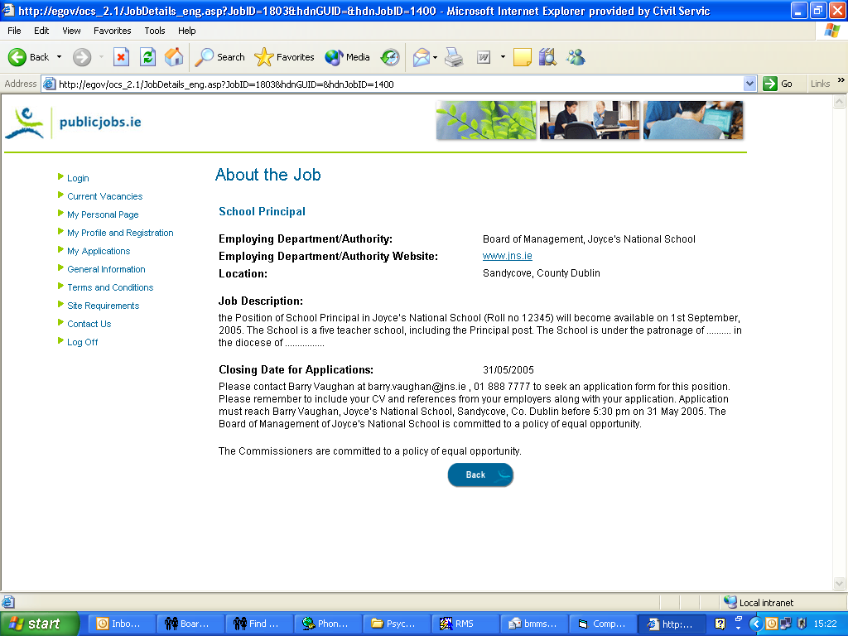
Please note that the name of the school, website address and contact details provided above are fictitious and are included for illustrative purposes only.

Sample: Short advertisement sample for national newspaper.

Principal teacher required from 1 September, 2005 for St. Mary’s NS, Cork RN: 12345X See www.publicjobs.ie.

