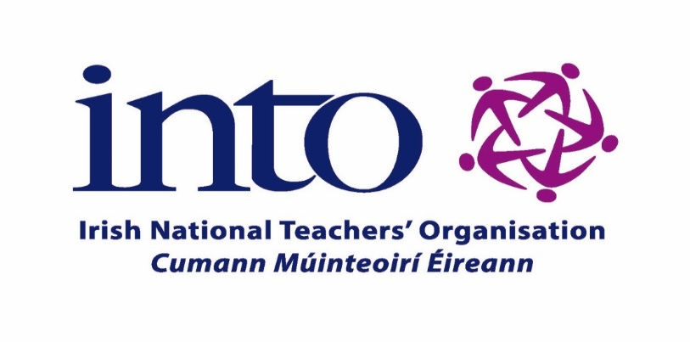

PRINCIPALS’ & DEPUTY PRINCIPALS’ BIENNIAL CONSULTATIVE CONFERENCE
Clayton Whites Hotel, Wexford
Friday 29th & Saturday 30th September 2023

Accommodation Options
Click the link to go to the website:

Crown Quarter Hotel

Talbot Hotel Wexford

Visit Wexford-Accommodation

Bed & Breakfast Wexford

